

American International University-Bangladesh (AIUB)  
**Department of Computer Science  
Faculty of Science & Technology (FST)**

**“Automated Toll Management System”**

A Software Requirement Engineering Project Submitted

By

|  |  |  |  |  |
| --- | --- | --- | --- | --- |
| **Semester: Spring_22_23** | | **Section:** | **Group Number:** | |
| SN | Student Name | Student ID | Contribution (CO1+CO2) | Individual Marks |
| 05 | S.M. BADSHA BAPPI | 19-39852-1 |  |  |
| 23 | TISHA RAHMAN | 19-41264-3 |  |  |
| 24 | S.M. MARUF | 19-41288-3 |  |  |
| 27 | KAZI EMADUZZAMAN GELANI | 19-41678-3 |  |  |

The project will be Evaluated for the following Course Outcomes

|  |  |  |
| --- | --- | --- |
| Evaluation Criteria | Total Marks (50) | |
|  | |
| Introduction, Format, Submission, Defense | [10 Marks] |  |
| System Overall Description & Functional Requirements | [10 Marks] |  |
| System Quality Attributes and Project Requirements | [10 Marks] |  |
| UML and E-R Diagram with Data Dictionary | [10 Marks] |  |
| UI/UX Prototyping | [10 Marks] |  |

Software Requirements Specification

for

< Automated Toll Management System >

Version 1.0 approved

Prepared by <Group 10>

<28 April 30, 2023>

Table of Contents

Revision History 3

1. Introduction 4

1.1 Purpose 4

1.2 Intended Audience and Reading Suggestions 4

1.3 References 6

2. Overall Description 6

2.1 Product Perspective 6

2.2 Product Functions 7

2.3 User Classes and Characteristics 7

2.4 Operating Environment 8

2.5 Design and Implementation Constraints 8

2.6 User Documentation 8

3. System Requirements 9

3.1 System Features 9

3.2 Non-Functional/Quality Requirements 11

3.3 Project Requirements 12

4. Design and Interface Requirements 13

4.1 UML Diagrams 13

4.2 Data Dictionary 15

4.3 UI/UX Design Specification 15

# Revision History

|  |  |  |  |
| --- | --- | --- | --- |
| **Name** | **Date** | **Reason for Changes** | **Version** |
|  |  |  |  |
|  |  |  |  |

# Introduction

## Purpose

* The product is an Automated Toll Management System which is a solution of the toll plaza problem by utilizing a laser detector to identify vehicles and verify their activated RFID tags to get toll fees through online. The system deducts the toll fee from registered users' accounts, while unregistered vehicles trigger camera captures of number plates for subsequent payment notifications.
* The SRS for this product covers user management, payment processing, RFID tag activation, toll plaza integration, notification system, security and privacy, and reporting and monitoring. It defines functionalities such as registration, login, account management, payment processing, RFID tag management, integration with toll plaza infrastructure, user notifications, security measures, and reporting capabilities. The SRS serves as a reference document that outlines the objectives and goals of the system, ensuring a clear understanding of the product's scope and deliverables.
* The Automated Toll Management System for toll plazas streamlines the toll collection process by using a laser detector to identify vehicles and check the activation status of their RFID tags. If the tag is active, the system deducts the toll fee automatically from the owner's account. In cases where the tag is inactive or missing, the system triggers a camera to capture photos of the vehicle's number plates, allowing for subsequent payment notifications via email. This system reduces time consumption, enhances security, and eliminates traffic congestion at toll gates. It provides convenience for travelers by eliminating the need to stop and pay manually. The system enables fee collection from both registered and unregistered users, contributing to revenue optimization. Additionally, it assists in preventing and recovering stolen vehicles by notifying all toll plazas and local authorities when a stolen vehicle passes through a toll plaza. The software aligns with corporate goals and business strategies by improving customer satisfaction, optimizing revenue, and promoting safety and security.

## Intended Audience and Reading Suggestions

* The intended audience for an SRS document for an Automated Toll Management System project includes project stakeholders, executives and decision-makers, end-users, quality assurance team, testers, and developers. The suggested reading focus for each audience is as follows:
* Project Stakeholders: They should concentrate on understanding the business objectives, functional and non-functional requirements, assumptions and constraints, and acceptance criteria specified in the SRS.
* Executives and Decision-makers: Their focus should be on the business objectives, high-level requirements, and overall approach presented in the SRS to align with the organization's goals and make informed decisions.
* End-users: They should pay attention to the use case scenarios and functional requirements relevant to their role within the organization to understand how the system will be used and how it will benefit them.
* Quality Assurance Team and Testers: Their focus should be on thoroughly reviewing the SRS document to ensure all requirements and constraints are captured accurately. They will use the SRS as a reference during the testing process to validate the software against the specified requirements.
* Developers: Developers will extensively use the SRS document to understand the system requirements and develop the software accordingly, ensuring that all the specified functionality and constraints are implemented
* The suggested sequence for reading the rest of this SRS document is as follows:

1. Introduction: Start with the introduction section, which provides an overview of the document, including its purpose, scope, and intended audience. This section sets the context for the rest of the document.
2. Product Overview: Proceed to the product overview section, which provides a high-level description of the Automated Toll Management System. This section outlines the system's goals, objectives, and key features, giving a clear understanding of what the system aims to achieve.
3. Functional Requirements: Move on to the functional requirements section, which describes the specific functionalities and features that the system should possess. This section outlines the system's behavior, use cases, and interactions with users and other components
4. Non-Functional Requirements: Continue with the non-functional requirements section, which outlines the quality attributes, performance expectations, security considerations, and other constraints that the system must meet. This section provides additional details on the system's performance, scalability, usability, and security requirements.
5. System Architecture: Proceed to the system architecture section, which provides an overview of the system's structure and components. This section may include diagrams or descriptions of the system's major subsystems, their relationships, and any external interfaces.
6. User Interface: Continue with the user interface section, which outlines the design and functionality of the system's user interface. This section may include wireframes, mockups, or descriptions of the user interface components and interactions.
7. Testing and Validation: Move on to the testing and validation section, which outlines the approach and strategies for testing the system to ensure its quality and compliance with requirements. This section may include test cases, scenarios, and acceptance criteria.

## References

[1] Balsamiq, “Balsamiq. Rapid, effective and fun wireframing software. | Balsamiq,” *Balsamiq.com*, 2019. <https://balsamiq.com/>

[2] <https://jpinfotech.org/online-toll-gate-management-system/>

[2] Lucidchart, “Online Diagram Software & Visual Solution | Lucidchart,” *Lucidchart*, 2017. <https://www.lucidchart.com/pages/>

# Overall Description

## Product Perspective

* Business Requirement for Automated Toll Management System:

1. Streamlined Toll Collection: The system aims to simplify the toll collection process by using laser detectors and RFID tag verification, eliminating the need for manual toll payments at the plaza.
2. Convenient Online Payments: Registered users can conveniently pay toll fees online, with the system automatically deducting the fees from their accounts, providing a hassle-free payment experience.
3. Integration of RFID Technology: The system seamlessly integrates with RFID technology to accurately identify vehicles and validate the activation status of RFID tags, ensuring precise toll fee calculations and reducing manual intervention.
4. Prompt Payment Notifications: Unregistered vehicles trigger camera captures of number plates, enabling timely payment notifications to be sent to vehicle owners for quick settlement of toll fees.
5. Secure and Compliant Operations: The system ensures secure payment processing, protects user financial information, and adheres to regulatory requirements, guaranteeing the privacy and security of user data and transactions.

* The Automated Toll Management System described in this SRS is a stand-alone product that addresses the challenges encountered in toll plaza operations. It offers a novel solution by introducing an automated and online payment system to streamline the toll collection process. This system is not part of an existing product family or a replacement for current systems but presents an innovative approach to toll management. It utilizes laser detectors to identify vehicles and RFID tags to verify toll fee activation. Through seamless integration with the existing toll plaza infrastructure, including cameras and laser detectors, the system captures vehicle data and enables efficient payment processing. It also interfaces with users' accounts, allowing for automatic toll fee deduction. A comprehensive diagram showcasing the system's components, interconnections, and external interfaces would provide a visual representation of its integration. Ultimately, the Automated Toll Management System aims to enhance the overall toll collection experience, optimizing efficiency, convenience, and user satisfaction while alleviating congestion at toll plazas through the introduction of modern technologies and online payment capabilities.

## Product Functions

1. User Registration:

Allows new users to create an account by providing personal information, username, and password and Performs validation checks on user input and ensures unique usernames.

Sends a confirmation email for email verification.

1. User Login:

Enables registered users to log in to their accounts using their credentials and verifies user information and grants access to system features.

1. Account Management:

Allows users to update their personal information, such as contact details or password and provides options to view and manage payment methods associated with the account.

1. RFID Tag Activation:

Allows users to activate and link RFID tags to their accounts for automatic toll fee deduction and verifies and stores tag information in the system's database.

5.Toll Fee Calculation:

Utilizes the laser detector to identify vehicles approaching the toll plaza and verifies the activated RFID tag and deducts the toll fee from the user's account automatically. Captures camera images of unregistered vehicles' number plates for subsequent payment notifications.

6.Payment Processing:

Facilitates secure and convenient online payment transactions and supports various payment methods, such as credit/debit cards or digital wallets. Generates payment receipts and sends them to users for reference.

7.Notification System:

Sends notifications to users regarding successful payments, account updates, or pending fees.

Alerts users about unregistered vehicles and provides instructions for payment.

8.Reporting and Monitoring:

Generates reports on toll transactions, user activity, and revenue for system administrators.

Monitors and tracks stolen vehicles passing through toll plazas, notifying local authorities.

9.Security and Privacy:

Implements robust security measures to protect user data, including encryption and access control. Complies with privacy regulations and safeguards user information.

10.System Administration:

Provides an administration panel for system owners and business owners.

Grants privileges to monitor and approve system-handled tasks. Enables management of user accounts, user levels, and privileges. Allows system backups and restorations.

## User Classes and Characteristics

* This system is a generic software which have two users,

1. The Admin: The authority or the control manager of the system

2. The General Users: the mass people who is going to need to pass the toll

* Characteristics of the user class:
* **The Admin**

Admin is the one who is controlling and monitoring the whole system and have all over access to the system

* **The General Users**

The General users are the main part of the system whose will going to use the system for hassle free toll passing for use the bridges.

## Operating Environment

* HARDWARE REQUIREMENTS:

System: Pentium Dual Core.

Hard Disk: 120 GB.

Monitor: 15’’ LED

Input Devices: Keyboard, Mouse

Ram: 1 GB

* laser Detector for verify activated RFID tags
* Cameras for capturing vehicles photos
* Operating system: windows
* Software:
* The software is designed to run on any platform above Microsoft windows 7.
* Microsoft .NET Frameworks 4.0 or above.

## Design and Implementation Constraints

* The developers of the Automated Toll Management System face several constraints that limit their options during development. These include adhering to corporate policies and regulatory requirements, accommodating hardware limitations such as timing and memory constraints, integrating with other applications following specific protocols, utilizing predetermined technologies, tools, and databases, considering parallel operations or phased implementation, meeting language requirements dictated by the project, complying with communications protocols for data exchange, addressing stringent security considerations, and following design conventions and programming standards for ease of maintenance. These factors guide the developers in making informed decisions and ensure that the system meets requirements within the defined limitations.

## User Documentation

* Providing User Documentation for the Automated Toll Management System provides comprehensive guidance and instructions for users to effectively utilize the system's features and functionalities. The documentation aims to facilitate a smooth user experience and ensure users can efficiently navigate and interact with the system. It includes the following key components:
* User Guide: This guide provides step-by-step instructions on how to register, create an account, and log in to the system. It explains the various user roles and their respective permissions, guiding users on how to perform specific tasks within the system.
* System Overview: This section provides an overview of the Automated Toll Management System, explaining its purpose, benefits, and the problems it addresses. It gives users a high-level understanding of the system's capabilities and how it enhances the toll collection process.
* Account Management: Users are provided with detailed instructions on managing their accounts. This includes updating personal information, adding or removing registered vehicles, managing RFID tags, and linking payment methods.
* Payment Processing: The documentation explains how users can make online payments for toll fees. It covers the steps to add payment information, set up automated payments, view transaction history, and resolve any payment-related issues.
* Notifications and Alerts: Users are informed about the different types of notifications they may receive, such as payment reminders, low balance alerts, and fine notifications. The documentation guides users on how to manage their notification preferences.
* Troubleshooting and FAQs: This section addresses common user queries and provides solutions to potential issues. It includes a comprehensive list of frequently asked questions and troubleshooting tips to help users resolve any problems they may encounter.
* Contact and Support: Users are provided with contact information for customer support, including phone numbers, email addresses, and support ticket submission instructions. This ensures users can reach out for assistance when needed.

The User Documentation aims to empower users with the knowledge and resources required to effectively utilize the Automated Toll Management System, maximizing their experience and ensuring a seamless toll payment process.

# System Requirements

## System Features

**Admin Features**

1. **Sign In**
   1. **Functional Requirements (FRs):** Admin can login to their system and the software shall allow the admin login credentials (username and password) will be verified with database records.

**Priority Level:** High **Precondition:** user have valid user id and password

1. **Access to User Information**

**Functional Requirements (FRs):** Admin can access to user information’s if required

1. **Change User Information**

**Functional Requirements (FRs):** Information can be edited by Admin if required

1. **View total inquiries/reports**

**Functional Requirements (FRs):** If suppose users send any inquiry or reports, then admin can check those and take necessary measurements.

1. **Respond to User Reports**

**Functional Requirements (FRs):** After getting any report or inquiry from user’s, admin can respond to those as well

1. **Tracking Vehicles**

**Functional Requirements (FRs):** With the help of this system admin can keep tracks of the vehicles in queue and can store any problematic case into their system database.

1. **Remove Users**

**Functional Requirements (FRs):** Admin can remove any user and if required they can also take legal steps

**User Features**

1. **Registration**

**Functional Requirements (FRs):** Users will have to register to our system first when they decide to use our system

1. **Login**

**Functional Requirements (FRs):** After successfully registering to our system, User’s will have to login to use our software

1. **Checking Notification**

**Functional Requirements (FRs):** Here User’s will get notification when they pass through the toll plaza and will also get notifications about their financial transactions required in toll

1. **Edit/Update Information**

**Functional Requirements (FRs):** If User’s need to update/edit any information in their profile, they will be able to do so as well

1. **Change Password**

**Functional Requirements (FRs):** Users can change password if they need to and during that time old password will be required as well for safety purpose.

1. **Recover Password**

**Functional Requirements (FRs):** If any of our user faces a situation where they have forgotten their password, then they could be retrieved through SMS and email verification.

1. **Add Payment Method**

**Functional Requirements (FRs):** There will be three payment methods which users can use. First comes Bank Account transaction where users will be able to directly transfer from their respective bank accounts.

Second option will be online payment gateways like Bkash, Nagad, Upay and Rocket. Simultaneously users can remove any previously selected payment method.

Lastly is the credit/debit card option where users will be able to pay through their cards like MasterCard, Visa or any local bank cards.

1. **Viewing Recent Transactions**

**Functional Requirements (FRs):** Users will be able track their recent transactions for example their history of how much they have spent on toll plaza till now, then they can view their transactions within a fixed timeline. Then in which of the toll plazas they have already visited and how much have been spending on each of them can also be traced. It also incorporates the net deduction of how much was spend and what is the current balance.

1. **Report Vehicle Loss**

**Functional Requirements (FRs):** If suppose a vehicle gets missing or disappears then they could be reported to our system and then authority will take necessary actions required. With this feature vehicle could be tracked and can be returned to the original owner safely.

## Non-Functional/Quality Requirements

1. Performance: The system should be able to handle a high volume of transactions efficiently, with minimal response times and no significant impact on the overall system performance. This requirement is essential to ensure a smooth and responsive user experience, especially during peak traffic periods.
2. Reliability: The system should be highly reliable, ensuring continuous operation without frequent downtime or disruptions. This requirement is crucial to maintain the functionality of the toll management system and prevent any loss of data or transaction errors.
3. Security: The system should have robust security measures in place to protect sensitive user data, transactions, and system resources. This includes secure authentication mechanisms, data encryption, access controls, and compliance with relevant security standards. Security is paramount to ensure the privacy and integrity of user information.
4. Usability: The system should be user-friendly and intuitive, with a clear and consistent user interface. It should require minimal training for users to understand and perform tasks effectively. Usability is important to enhance user satisfaction and productivity, reducing the learning curve and potential errors.
5. Maintainability: The system should be easy to maintain and update, with well-documented code and modular design. It should support future enhancements, bug fixes, and system upgrades without major disruptions. Maintainability is critical for the long-term sustainability and evolution of the toll management system.

## Project Requirements

* **Tools:** The system developer needs selenium tools in perform testing activities in week 6

# Design and Interface Requirements

## UML Diagrams

* Use Case Diagram:

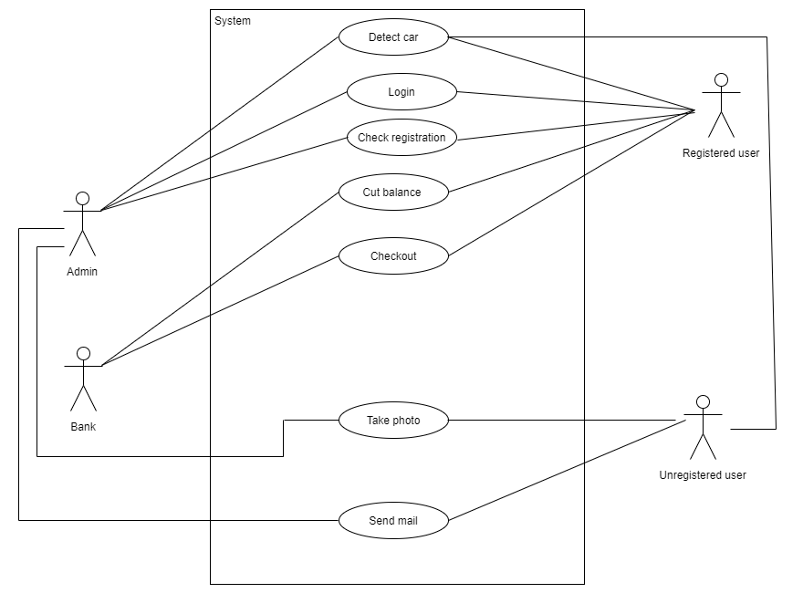

Here, when a registered car passes through the toll plaza the system detects the car and checks registration and cuts balance from the users account. This can be monitored by the admin. The bank will be responsible for deducting balance from the user’s account and checkout. When an unregistered user passes through the sensor detects the car and a photo is taken of the number plate and an email is sent to the respective owner to pay the fees in time to avoid fines.

* Class diagram:

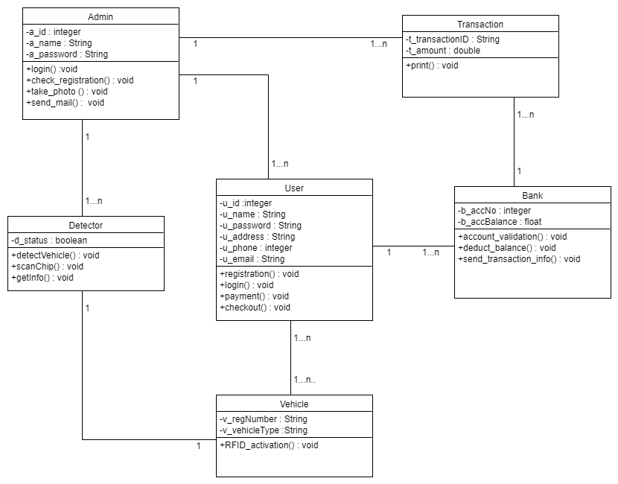

Here in the Class diagram, there are a total of six classes. They are Admin, User, Detector, Vehicle, Bank, Transaction. There is one to many relations between admin and user as well as the detector and transaction, one to many relations between user and bank, many to many relations between user and vehicle and one to one relation between detector and vehicle.

## Data Dictionary

|  |  |  |  |
| --- | --- | --- | --- |
| Toll Plaza | User Table | Vehicle Table | Transaction Table |
| PlazaID (Primary Key) | UserID (Primary Key) | VehicleID (Primary Key) | TransactionID (Primary Key) |
| PlazaName | FirstName | UserID (Foreign Key) | VehicleID (Foreign Key) |
| Location | LastName | VehicleNumber | TollPlazaID (Foreign Key) |
| Capacity | Email | RFIDTagNumber | Amount |
|  | Username | ActivationStatus | Timestamp |
|  | Password |  |  |

## UI/UX Design Specification

The system contains vehicle’s RFID (Radio-frequency identification) tag and at times when the tag is inactive or not discovered the laser activates the camera, which takes two photos: one of the rear vehicle number plate and the other of the back nameplate. Then, based on the registration number plate an email will be sent to the owner, requesting payment within a specific time period to avoid a fine.

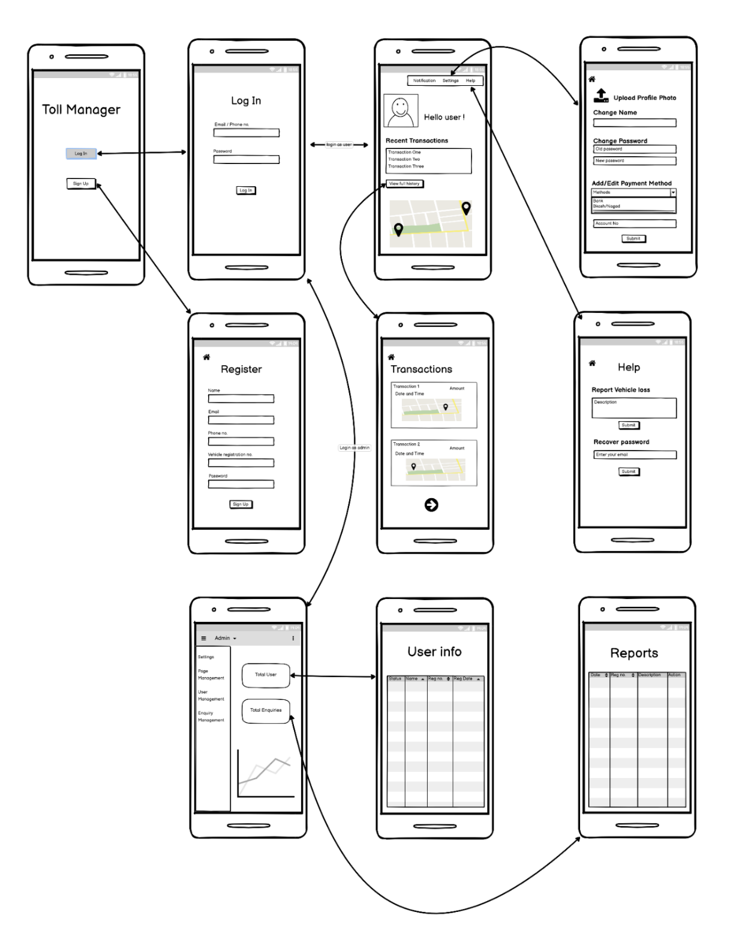

Figure 1: - Prototype Design